MAKE EVERY SONG A LOVE SONG
Celebrate Valentine’s Day with Sennheiser

Wedemark, February 1, 2021 – All you need is love… but a little music never hurts. Feelings can be hard to put into words so why not express yourself through song this Valentine’s Day with a pair of headphones and a list of songs that remind you of the person who matters most to you. With styles to match every budget, every whim and every desire, Sennheiser will help make the romance last longer with a gift that keeps on giving long after the holiday.

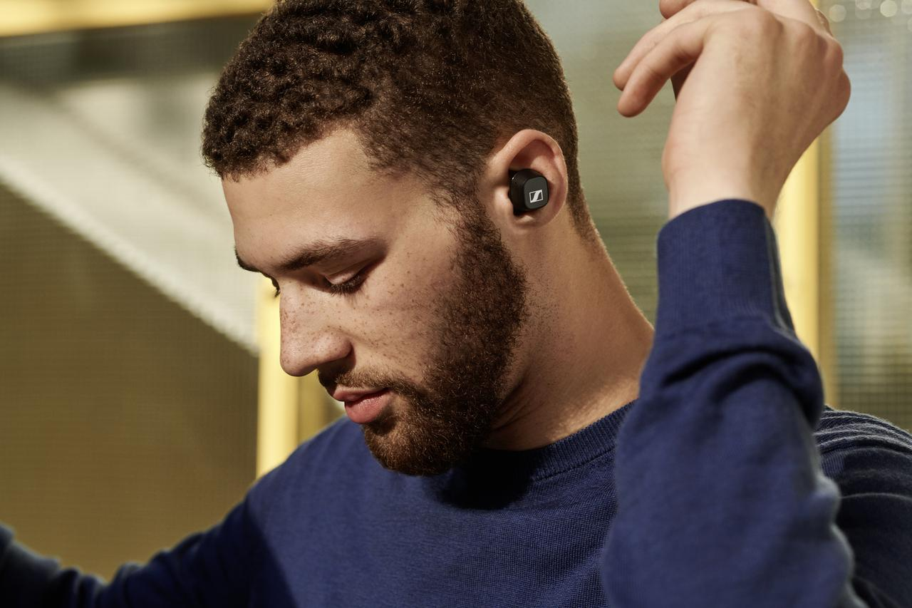
For the music lover

CX 400BT True Wireless
+ Astonishing sound thanks to Sennheiser’s 7mm dynamic drivers
+ Personalized listening experience with built-in equalizer so they can curate a sound that is perfect for them
+ Customizable touch controls
+ 7-hour battery life (+13 via the case)
+ Available in black or white
Current promotional price: 99 EUR

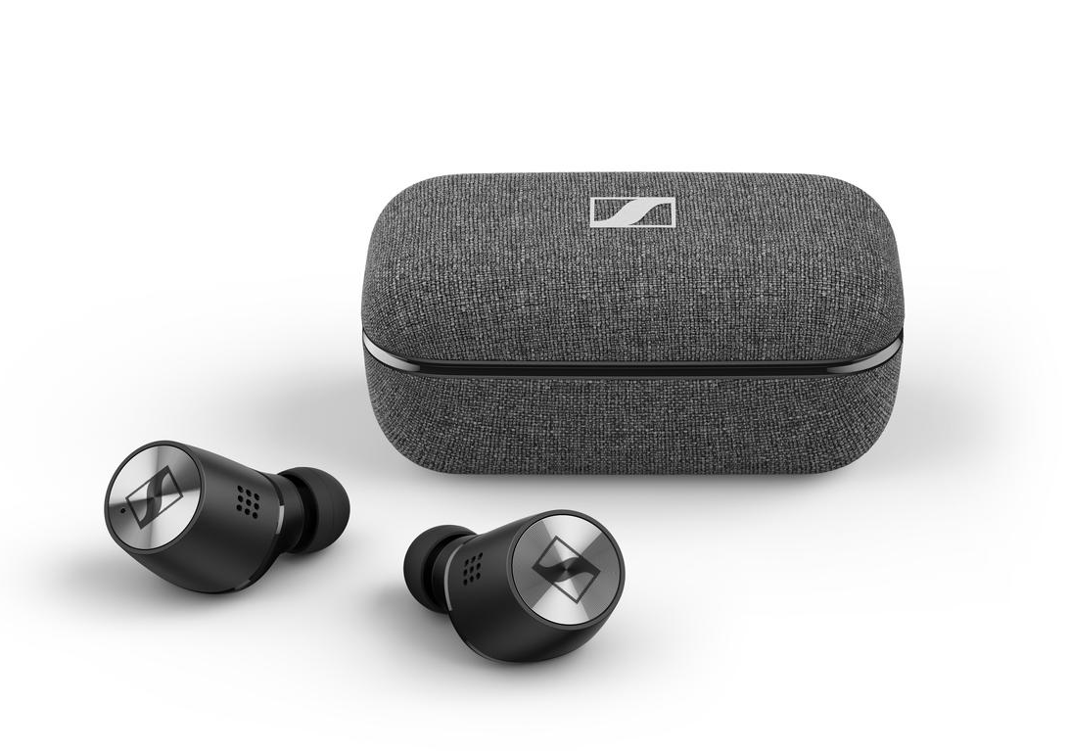
True wireless earbuds they’ll adore

MOMENTUM True Wireless 2
+ Exceptional sound featuring Sennheiser’s 7mm dynamic drivers
+ Active noise cancellation
+ Transparent Hearing
+ Customizable touch controls
+ Smart Pause feature
+ Exquisite craftmanship
+ 7-hour battery life (+21 via the case)
+ Available in black or white
MSRP: 299 EUR

Earbuds that delight on a budget

CX 150BT
+ The perfect balance of audio quality, comfort, durability and affordability
+ Bluetooth 5.0 technology as well as AAC and SBC codec support
+ 10-hour battery life and convenient USB-C charging
+ Available in black or white
MSRP: 69 EUR

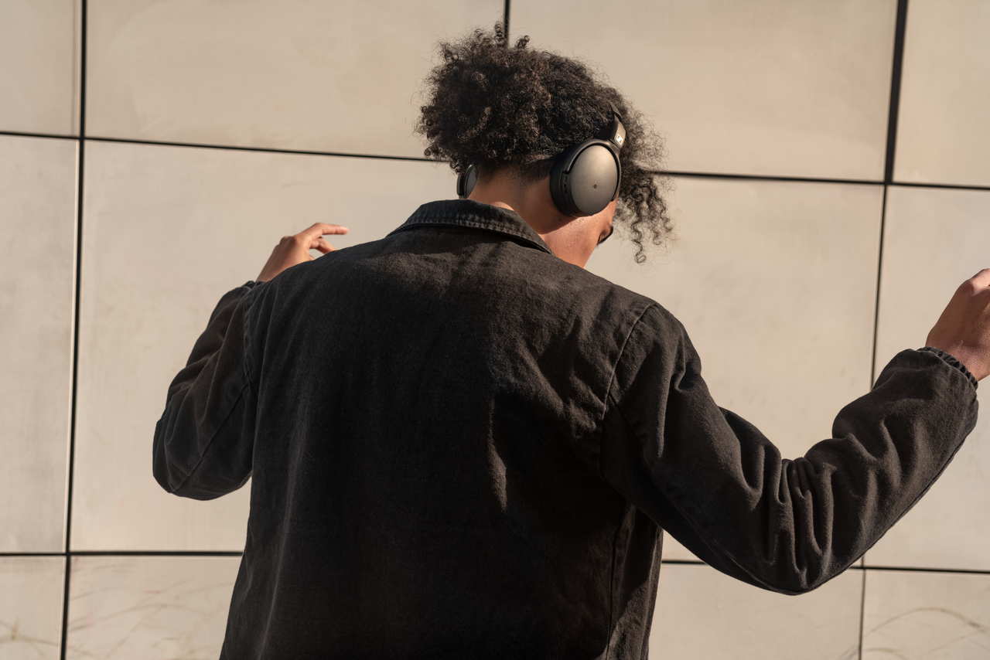
Everyday audio hero

HD 350BT
+ Great sound that can be customized
via Smart Control app
+ Bluetooth 5.0 technology and AAC, AptX™ and AptX™ Low Latency codecs
+ Impressive 30-hour battery life
+ Ergonomic comfort and minimalist style
+ Available in black or white
MSRP: 99 EUR
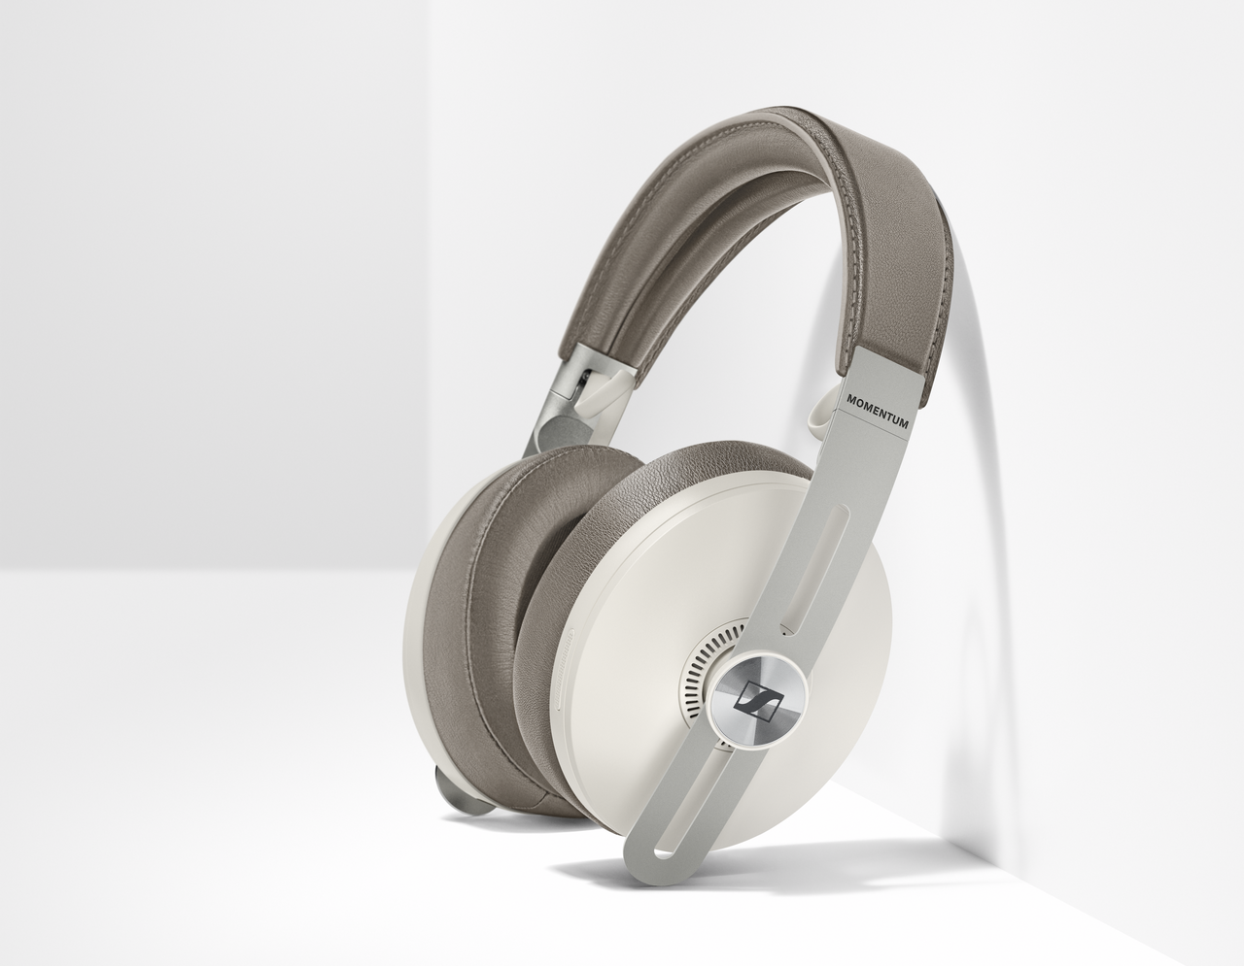
Treat them to an oasis of calm
MOMENTUM WIRELESS
+ Outstanding sound performance
+ 3 ANC modes for when they want to get lost in the music (or escape the insanity that is everyone’s home these days)
+ Transparent Hearing feature
+ Auto On/Off and Smart Pause
+ Luxurious design with soft leather on
the earpads and headband
+ 17-hour battery life
+ Tile Bluetooth tracker
+ Available in black or sandy white
MSRP: 399 EUR

For the perfectionist in your life
MKE 200
+ Directional microphone for enhanced in-camera audio – the perfect gift to fuel your partner’s creativity
+ Compact design with sleek finish
+ Integrated wind protection and internal suspension mount to minimize handling noise
+ Interchangeable 3.5mm (1/8") TRS and
TRRS connectivity for DSLRs/DSLMs or
mobile devices
+ Standard cold shoe mount for universal
use
+ Battery-free operation
MSRP: 99 EUR

About Sennheiser
Shaping the future of audio and creating unique sound experiences for customers – this aim unites Sennheiser employees and partners worldwide. Founded in 1945, Sennheiser is one of the world’s leading manufacturers of headphones, loudspeakers, microphones and wireless transmission systems. Since 2013, Sennheiser has been managed by Daniel Sennheiser and Dr. Andreas Sennheiser, the third generation of the family to run the company. In 2019, the Sennheiser Group generated turnover totaling €756.7 million. www.sennheiser.com

Global Press Contact
Sennheiser electronic GmbH & Co. KG
Jacqueline Gusmag
Communications Manager Consumer
T: +49 (0)5130 600-1540
jacqueline.gusmag@sennheiser.com

